Lec4
- Search About devops and make a page to a page and a half.
- Create a class and make an object from it.
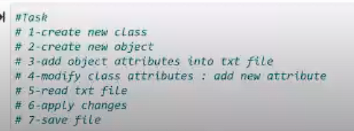

- Project for next Thursday

Lec 5
- Different types of distribution
- What do when data is not normal distribution.

Lec 6
- What is recursion , tabulation, memoization
- Processors of iphones
- What are solid principles

Lec 7
- How to print all the days of a counted item in pandas

